

SECR1013 DIGITAL LOGIC

LIFT CONTROLLER SYSTEM

Prepared by
- NG YAW KUAN A25CS0292
2. WONG JING JIE A25CS0159
3. JAMES SIM CHIA TAI A25CS0072
4. TERENCE LIM JIAN YUAN A25CS0364

LECTURER: DR. TS. RAJA ZAHILAH BINTI RAJA MOHD. RADZI

Dedication and Acknowledgement

This project is dedicated to our lecturer, Dr. Ts. Raja Zahilah binti Raja Mohd. Radzi. We want to give our sincere gratitude to our lecturer, Dr. Ts. Raja Zahilah binti Raja Mohd. Radzi for her guidance and valuable advice in Digital Logic. Her clear explanations had enhanced our understanding of Digital Logic. This understanding has helped us complete this project efficiently. Moreover, we had also learned about many practical pieces of information and real-life applications of Digital Logic, beyond its theoretical information. This provides us with a real-life scenario experience about this course.

Besides that, we would like to give our sincere thanks to our group members. The collaborative effort of our team has been the key to success in order to reach our achievement. Each member played a significant role by providing their own unique set of skills to complete their tasks.

Through this project, we’ve been inspired to think that thinking, problem-solving, and teamwork skills are indispensable in order to succeed. Thank you, Dr. Ts. Raja Zahilah binti Raja Mohd. Radzi and our team for an exceptional learning journey.

TABLE OF CONTENTS
1.0 OBJECTIVE 4
2.0 BACKGROUND 4
2.1 Combinational circuit components 4
2.2 Sequential circuit components 4
2.3 Features 5
3.0 PROBLEM STATEMENT 5
4.0 SUGGESTED SOLUTION 5
4.1 Block Diagram 6
4.2 State Diagram 7
4.3 Next Step and Flip Flop Transition Table 8
4.4 Karnaugh Map (K-Map) 9
5.0 IMPLEMENTATION 10
5.1 Floor Switches 10
5.2 Main Function (JK flip-flop) 11
5.3 Clock Disabler 11
5.4 Password Comparator 12
5.5 Floor Comparator 13
5.6 Sound Notification 14
5.7 Current Floor Display 15
6.0 Full Digital Electronics Deeds Circuit 16
7.0 Conclusion 17
8.0 References 17
9.0 Appendices 18

- OBJECTIVE

The objectives of this project are:
- To design a 3-bit synchronous counter for the lift system controller of an 8-level building.
- To implement the basic principles of combinational and sequential logic circuits studied in the course towards an actual lift controller system.
- To test and check the functionality of the designed circuit with the help of the Digital Electronic Deeds.
- To utilise the components of combinational and sequential circuits.
- To develop problem-solving, logical thinking, and teamworking skills within group members through collaborative group projects.
- To demonstrate and explain the operation of the lift system.

- BACKGROUND

In this project, our target is to implement a lift system controller of an 8-level building using a 3-bit synchronous counter. This system ensures safety, as it requires users to tag the card and enter the 4-bit numerical password to access the lift. To make this system more advanced, we have added extra features, which include sound notification when it reaches the target floor and the lift button.

  - Combinational circuit components

- Basic gates
- Switches
- Comparator
- LEDs

  - Sequential circuit components

- JK flip-flops
- Clock disabler

  - Additional Features
- 4-bit password
- Card reader
- Sound notification
- Lift button

- PROBLEM STATEMENT

In today’s world, many security problems have occurred since lifts lack strong security systems. This will cause people who are not authorised to intentionally use the lift and access other people’s floors. Therefore, to help society solve this problem, we decided to create a new lift system using the Digital Electronics Deeds Simulator. In this system, it only ensures that the authorised owner or approved individuals can use the lift by verifying the card identifier and the password system. By the wider implementation of this system in society, cases of unauthorised access could be significantly reduced.

- SUGGESTED SOLUTION

In order to solve the security problem, we had proposed the implementation of a combination of a card and 4 binary-digit password-protected solution. The proposed solution integrates a few advanced electronic components, including a 3-bit comparator to match the floor, a 4-bit comparator to match and verify the password, basic gates to route signals, and JK flip-flops for sequential circuit counting. Initially, users are required to swipe their card and enter a password to gain access to the lift. The lift will be activated only after the user has tapped their card to the card reader and entered the correct password in the password reader; otherwise, it will remain idle. After a successful authentication, users can choose the direction of the lift by using an Up/Down switch, in which 0 represents upward, while 1 represents downward movement, and the option to choose their desired floor level. The lift operation will stop via the 3-bit floor comparator upon reaching the floor level selected by the user, and a sound notification will notify the user that the lift has reached the desired floor. The suggested solution will provide a secure and effective authentication system, ensuring only authorized personnel can operate the lift. The proposed system will be designed using the Digital Electronics Deeds Simulator.
  - Block Diagram

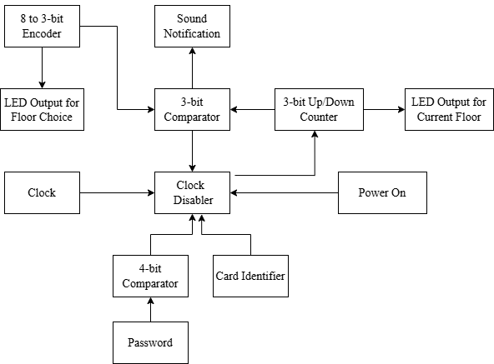

  - State Diagram
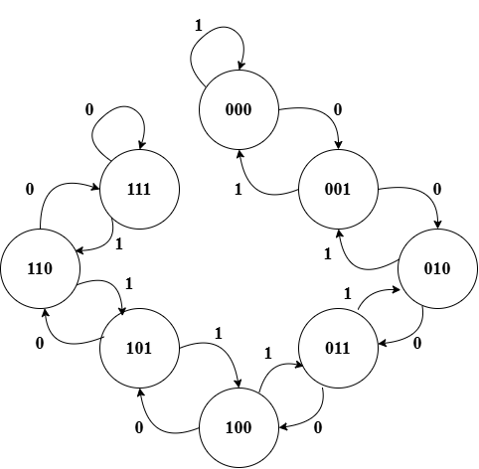

  - Next Step and Flip Flop Transition Table

Input,  X | Present State |  |  | Next State |  |  | JK Flip Flop
Input,  X | Q₂ | Q₁ | Q₀ | Q₂₊ | Q₁₊ | Q₀₊ | J₂ | K₂ | J₁ | K₁ | J₀ | K₀
0 | 0 | 0 | 0 | 0 | 0 | 1 | 0 | X | 0 | X | 1 | X
0 | 0 | 0 | 1 | 0 | 1 | 0 | 0 | X | 1 | X | X | 1
0 | 0 | 1 | 0 | 0 | 1 | 1 | 0 | X | X | 0 | 1 | X
0 | 0 | 1 | 1 | 1 | 0 | 0 | 1 | X | X | 1 | X | 1
0 | 1 | 0 | 0 | 1 | 0 | 1 | X | 0 | 0 | X | 1 | X
0 | 1 | 0 | 1 | 1 | 1 | 0 | X | 0 | 1 | X | X | 1
0 | 1 | 1 | 0 | 1 | 1 | 1 | X | 0 | X | 0 | 1 | X
0 | 1 | 1 | 1 | 1 | 1 | 1 | X | 0 | X | 0 | X | 0
1 | 0 | 0 | 0 | 0 | 0 | 0 | 0 | X | 0 | X | 0 | X
1 | 0 | 0 | 1 | 0 | 0 | 0 | 0 | X | 0 | X | X | 1
1 | 0 | 1 | 0 | 0 | 0 | 1 | 0 | X | X | 1 | 1 | X
1 | 0 | 1 | 1 | 0 | 1 | 0 | 0 | X | X | 0 | X | 1
1 | 1 | 0 | 0 | 0 | 0 | 1 | X | 1 | 1 | X | 1 | X
1 | 1 | 0 | 1 | 1 | 0 | 0 | X | 0 | 0 | X | X | 1
1 | 1 | 1 | 0 | 1 | 0 | 1 | X | 0 | X | 1 | 1 | X
1 | 1 | 1 | 1 | 1 | 1 | 0 | X | 0 | X | 0 | X | 1

  - Karnaugh Map (K-Map)

J₂ K₂
Q₁Q₀  XQ₂ | 00 | 01 | 11 | 10 |  | Q₁Q₀  XQ₂ | 00 | 01 | 11 | 10
00 | 0 | 0 | 1 | 0 |  | 00 | X | X | X | X
01 | X | X | X | X |  | 01 | 0 | 0 | 0 | 0
11 | X | X | X | X |  | 11 | 1 | 0 | 0 | 0
10 | 0 | 0 | 0 | 0 |  | 10 | X | X | X | X
$$J_{2}= \overline{X}⋅{Q_{1}⋅Q}_{0} K_{2}= X⋅\overline{Q_{1}}⋅\overline{Q_{0}}$$

J₁ K₁
Q₁Q₀  XQ₂ | 00 | 01 | 11 | 10 |  | Q₁Q₀  XQ₂ | 00 | 01 | 11 | 10
00 | 0 | 1 | X | X |  | 00 | X | X | 1 | 0
01 | 0 | 1 | X | X |  | 01 | X | X | 0 | 0
11 | 1 | 0 | X | X |  | 11 | X | X | 0 | 1
10 | 0 | 0 | X | X |  | 10 | X | X | 0 | 1
$$J_{1}=\overline{X}⋅Q_{0}+X⋅Q_{2}⋅\overline{Q_{0}} K_{1}=X⋅\overline{Q_{0}}+ \overline{X}⋅\overline{Q_{2}}⋅Q_{0}$$

J₀ K₀
Q₁Q₀  XQ₂ | 00 | 01 | 11 | 10 |  | Q₁Q₀  XQ₂ | 00 | 01 | 11 | 10
00 | 1 | X | X | 1 |  | 00 | X | 1 | 1 | X
01 | 1 | X | X | 1 |  | 01 | X | 1 | 0 | X
11 | 1 | X | X | 1 |  | 11 | X | 1 | 1 | X
10 | 0 | X | X | 1 |  | 10 | X | 1 | 1 | X
$$J_{0}= \overline{X}+Q_{2}+Q_{1} K_{0}=X+\overline{Q_{2}}+\overline{Q_{1}}$$

- IMPLEMENTATION
  - Floor Switches
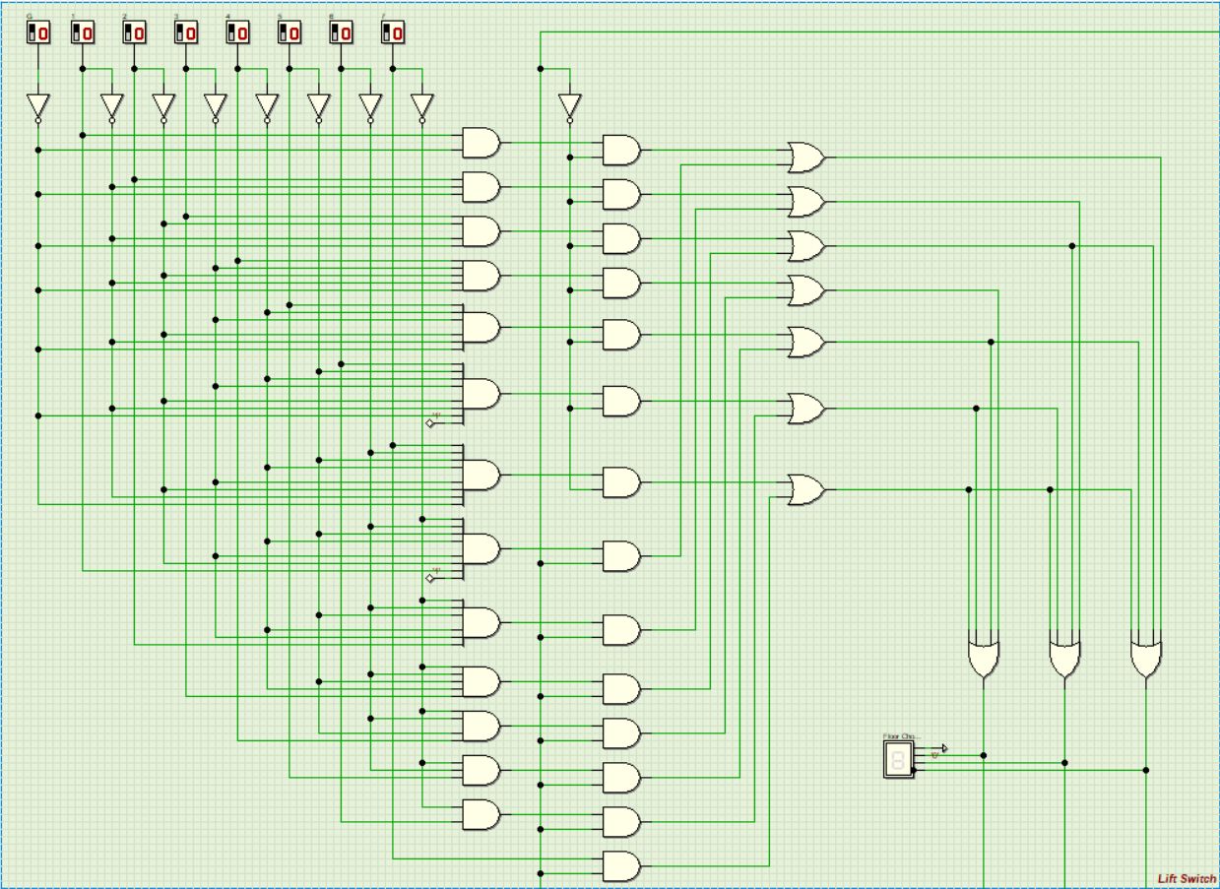

We had implemented an 8-to-3 bit bidirectional priority encoder to represent the switches of the lift floor (G to 7). This encoder allows the user to select multiple floors simultaneously, as in real life, while ensuring that only one target floor is output or processed at a time. The encoder operates at two different priority modes that are based on the direction in which the lift travels. When the lift is moving upwards, the encoder will prioritise the lowest chosen floor; when the lift is moving downwards, the encoder will then prioritise the highest chosen floor. This encoder allows the lift to serve the floors ascending or descending in a sequential manner based on the selected movement for the lift. The output of the encoder is the selected prioritised floor through a 3-bit binary value (000 to 111), which is then sent to the floor comparator for further logic operations.

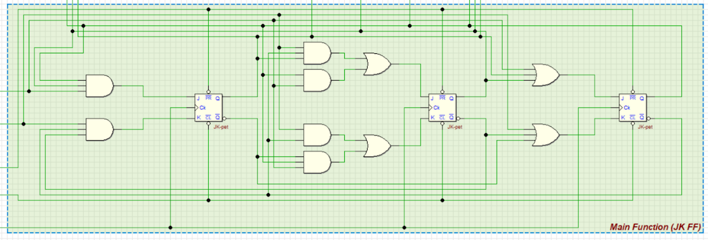
  - Main Function (JK FF)

We use a 3 JK flip-flop in the main function of the lift system project. This main function is used to determine whether the lift can start operating or stop operating. Output from the clock disabler acts as the clock for all JK flip-flops. The counting up or down process will be stopped when the clock pulse is no longer receiving or the lift has already reached the target floor.

  - Clock Disabler
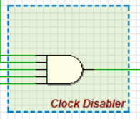

We set up the clock disabler by using a 5-input AND gate. This AND gate will only be active while 5 input resources are in a high state, which are the clock generator, password comparator, floor comparator, card reader, and power switch. Meanwhile, the output of the 5-input AND gate is connected to the clock input in each JK flip-flop. This 5-input AND gate design is to determine the start and stop of the lift operation while the current floor is the same as the desired floor entered by users.

  - Password Comparator

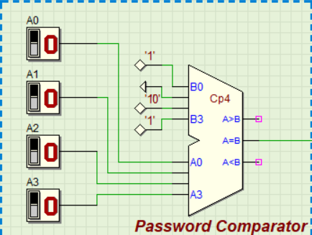

We had implemented a 4-bit MSI comparator as a password comparator as an authentication method. The user enters the password through 4 binary input switches, with each representing a binary value. These input values are then compared with the preset codes of the password stored inside the system (Password: 1101) with the help of combinational logic circuits. The comparator outputs the value 1 if and only if the user has entered the exact password stored inside the system, and allows the clock to be activated if other conditions are met, which ensures only the authorised personnel can access the lift, thus enhancing the security of the lift control system.

  - Floor Comparator

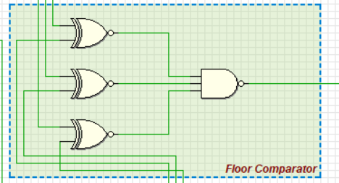

We had set up a floor comparator using a 3-input NAND gate and three XNOR gates. These components are used to compare two sources of data, which are the lift input switches and the current floor level of the lift. The lift input switches are entered by the user, while the current floor level is taken from the outputs of the JK flip-flops over time. Each XNOR gate compares a corresponding bit from both sources, starting from the least significant bit (LSB) to the most significant bit (MSB). When both bits are different, the XNOR gate produces an output of 0, and vice versa, which is then sent to the NAND gate. The outputs from all comparator stages are combined and processed by the NAND gate. Once all bits are equal (every XNOR outputs a 1), the NAND gate will then produce an output of 0. Then, this output is sent to the clock enabler to stop the counting process of the lift.

  - Sound Notification
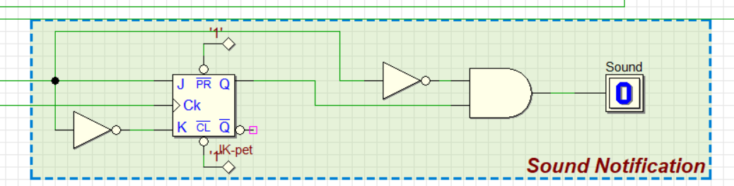

We configured a JK flip-flop acting as a D flip-flop by fetching the output of the floor comparator to the J terminal and the inverted output of it to the K terminal. The logic is controlled by an AND gate with two inputs: the inverted output from the floor comparator (upper input) and the JK flip-flop (lower input). Initially, when the current floor is not the same as the desired floor, the floor comparator outputs the value 1, and the value is inverted to 0 to be the upper input of the AND gate. The same input from the floor comparator also enters the JK flip-flop, which is then stored by the JK flip-flop and output at the next clock edge. This ensures the AND gate outputs 0 while the floor is not the same. At the moment when the current floor is the same as the desired floor, the floor comparator outputs the value 0, which is then inverted to 1 at the upper input of the AND gate, and the lower input was the yet updated value of the JK flip-flop (output of the previous clock edge for the JK flip-flop), which is 1, causing the AND gate to produce an output of 1, which activates the sound notification. At the next clock edge after reaching the desired floor, the JK flip-flop updates and outputs the input it receives at the previous clock edge, which is 0, leading to an output of 0 for the AND gate, which will deactivate the sound notification, making the sound notification last exactly one clock cycle.

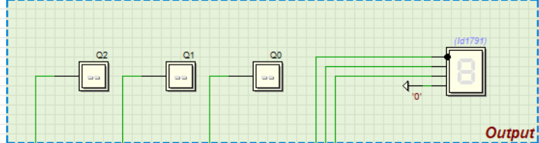
  - Current Floor Display

The current floor information is obtained from the 3-bit up/down counter, which shows the lift’s floor position in binary form. When the lift moves up, the counter increments; when the lift moves down, the counter decrements on each clock pulse. The output of the counter represents the current floor number. These 3-bit counters are connected to a decoder and display unit, which converts the binary value into a format that can be read by humans. LEDs are used to represent the floor number. When the counter output changes, the display will be immediately updated.

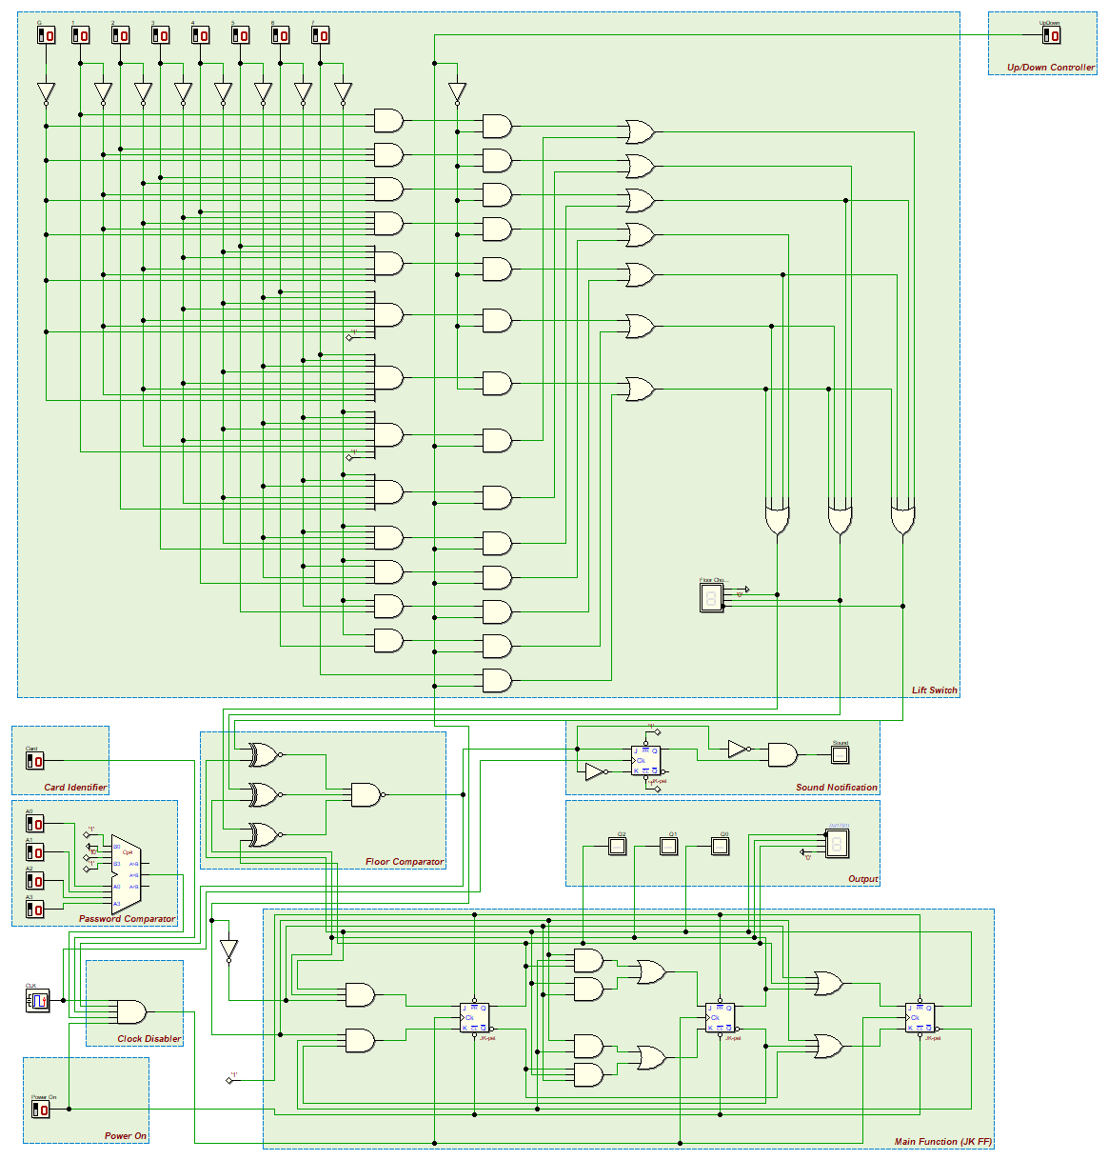
- FULL DIGITAL ELECTRONICS DEEDS CIRCUIT

- CONCLUSION
To recapitulate, this project has successfully demonstrated the design and implementation of an elevator controller system using combinational and sequential digital logic circuits. The system was designed by implementing a 3-bit synchronous counter and key components such as JK flip-flops, encoders, comparators, clock disables, password, and sound notification modules. These components collaborate to make sure accurate floor selection, access control, and lift operation.

By using Digital Electronics Deeds, the lift system can operate correctly according to user inputs. This project enhanced our understanding of digital logic and provided us with valuable practical experience in applying digital electronics concepts in real-world scenarios. In the future, we are excited to implement more complex circuits with more exciting options, and we are also looking forward to apply our knowledge in related fields and applying it to real-life situations.

- REFERENCES

[1] Floyd, T.L. (2022). Digital Fundamentals (11th ed.) Pearson.

[2] Mohd Fo’ad, R. et al. (2025). Digital Logic Fifth Edition. Johor Bahru: Faculty of Computing, UNIVERSITI TEKNOLOGI MALAYSIA.

[3] Mohd Fo’ad, R. et al. (2025). Digital Logic Lab Manual. Johor Bahru: Faculty of Computing, UNIVERSITI TEKNOLOGI MALAYSIA.

- APPENDICES

NAME | NG YAW KUAN | TERENCE LIM  JIAN YUAN | WONG JING JIE | JAMES SIM  CHIA TAI
TASKS | Deeds Simulation circuit design
TASKS | Objective | Suggested solution | Problem Statement | Dedication and Acknowledgement
TASKS | Background | Reference & Appendices | Table of contents | Conclusion and Reflection
TASKS | Implementation
TASKS | Video Presentation & Editing

Discussion Photo

